Design and Post-Mortem Document

Team Members and Student IDs:

Gal Levy: 6798-4452

Rahul Dani: 9013-1693

Thomas Mulligan: 3693-3819

Diagram method galEnemy:

If not vulnerable and Ms. Pacman is not close to a power pill, defender goes towards Ms. Pacman

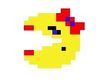



If vulnerable or Ms. Pacman is near a power pill, defender goes further away from Ms. Pacman. Goes the same direction as Ms. Pacman if available, and if not defender goes up.



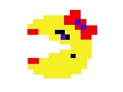



Diagram method rahulEnemy:

If not vulnerable, the defender tries to approach (goes towards) Ms. Pacman. This bot acts as a sarificial bot to compliment galEnemy. As it allows the game to progress without it being a standstill hence not allowing Ms.Pacman to win based on time.





If vulnerable, the defender flees (goes away from) Ms.Pacman.





Diagram method thomasBot:

If vulnerable: It figures out an effective path to get away from Ms. Pacman.



If invulnerable: It figures out an effective path to get to Ms. Pacman using the portals in the wall also.



Individual contributions: Each team member created a method that a defender would use to determine which direction to go to. Gal made the method galEnemy, Rahul made the method rahulEnemy, and Thomas made the method thomasBot.

galEnemy: This method first checks to see if the defender is in vulnerable mode and if Ms. Pacman is near a power pill. If either is true, the method takes Ms. Pacman’s direction into account first. If the same direction that Ms. Pacman is going in is available, the defender will go in that direction to further itself from Ms. Pacman to avoid being consumed. If that direction isn’t available, the defender takes the x and y coordinates into account of Ms. Pacman in relation to itself to determine which direction furthers itself from Ms. Pacman the best. If Ms. Pacman isn’t near a power pill and the defender is not in vulnerable mode, the defender uses the get path method to go towards Ms. Pacman in attempt to consume her.

rahulEnemy: This method first checks to see if the defender is in vulnerable mode. If it is, the method determines the location of Ms. Pacman and uses this as the target in the getNextDir method. The Boolean parameter is set as false so that the defender will flee Ms. Pacman so it won’t get eaten. If the enemy is not in vulnerable mode, the method uses the same location and method but sets the parameter to true to chase Ms. Pacman. This defender also acts as the sacrifice to approach Ms. Pacman when she is hovering before a power pill so that the time doesn’t run out and she gets all the points on the board.

thomasBot: This method also checks the vulnerability of the defender. The method uses Ms. Pacman’s direction and the x y coordinates of both the defender and Ms. Pacman to determine which direction to go to. If this defender is chasing Ms. Pacman and is one node away from her, the defender will continue to follow Ms. Pacman by matching the direction she is going towards. The getPathTo method is used to help determine the x and y coordinates that will determine which direction the defender goes. This defender also acts as a sacrifice to go towards Ms. Pacman when she is hovering right before a power pill.

Overall Strategy: The team’s strategy was to have three different classes of defenders. While all would attack Ms. Pacman, one would act as a sacrifice if she got near a power pill since Ms. Pacman is smart enough to hover around a power pill to either run the clock out or until a defender goes near her so that she can eat it. One method would focus on the proximity of Ms. Pacman to the power pill. In the case, where Ms. Pacman is close to the power pill, it would start to move in the opposite direction to avoid being eaten. All would attack Ms. Pacman when she isn’t vulnerable using different methods to increase the likelihood of defeating Ms. Pacman.

Evaluation: Overall the defenders did their job and limited Ms. Pacman to getting the score needed for 100% performance. Each defender had unique behavior which helped to attack Ms. Pacman with three different strategies. The team worked well together and helped each other to accomplish three unique behaviors for the defenders. The fact that Ms. Pacman hovered before a power pill to maximize her score affected our team behavior but ultimately, we were over to overcome this to reach 100% performance by our defenders. One of the defenders had to sacrifice itself when this happened, limiting its score but raising the performance of the entire team.

Successes and Failures: Throughout this project, there were many areas where our team had failed at first, but through trial and error we were able to come up with the solutions to these problems. One of the first hardships we encountered was Ms. Pacman’s behavior around the power pill. At first, we did not understand how our score numbers were high but using visual provided, we were able to see that Ms. Pacman would constantly turn left and right around the power pill. To counter this situation, we had to work as a team and chose one of our methods to be sacrificial in order for the other ghosts to attack Ms. Pacman. In our case, this sacrificial method was rahulEnemy, which would not account for the fact that Ms. Pacman is near a power pill because if it did, Ms. Pacman would get all the points due to time. A success we had for this project was to use the appropriate methods at the right place. Initially we had not planned on accounting for the power pill or Ms. Pacman’s proximity to one of them. We recognized that the defenders would be smarter if they knew when to target Ms. Pacman and when to run away including when Ms. Pacman is close to the power pill. Through these successes and failures, we were able to truly see the faults in our code and with each fault came new ideas that vastly improved the effectiveness of the defenders, leading to a better score as well as shorter runtimes.

Team Reflection: As a team, we worked well together. We met multiple times and worked together to accomplish getting a score below the example score over 100 trials. We helped each other with methods and enjoyed that this was a group project since it made the experience better. Upon completion of the basic structure of each defender behavior. We experimented with different values and organizations for the defender behaviors to optimize getting the lowest score with the methods we had. The group aspect really made it helpful as opposed to the individual previous projects. We helped each other with our weaknesses and improved our programming abilities with this project. The fact that this project could have been accomplished in countless ways encouraged us to brainstorm ideas together to come up with strategies that were unique and related to each of us. While there are some negatives to working as a team such as the need to depend on other people, we think the positives greatly outweighed the negatives of teamwork. This experience will help us when we have jobs that have team projects to accomplish software tasks. In conclusion, we worked well as a team together and accomplished the goal we were set out to reach. We made new friends and learned more about programming while having fun.

Gal Reflection: I enjoyed this project because it was different than the other projects we did. I liked that we were given freedom to choose the strategy and behavior of our defender. Tying in the stuff we learned in class to a visual game also made this experience fun, especially since this is a classic arcade game that most people are familiar with. I also enjoyed that it was in groups this time since each group member helped each other and made the overall experience better. I felt that this final project tied in most of the concepts that we learned this year such as polymorphism and object oriented programming. An idea I had was to have the defenders communicate with each other to trap Ms. Pacman but I felt it was too complicated and above my skill level to accomplish. Eventually I would like to figure out how to accomplish this. I enjoyed that there wasn’t a limit to this project. The methods can always be improved and further limit Ms. Pacman’s score. Even though this project had some performance problems across different platforms and was frustrating at first, it ended up being a satisfying experience that tested my knowledge of programming fundamentals.

Rahul Reflection: This project was a unique one, in the sense that it wasn’t something we made from scratch like the other ones. I liked the idea of this project because it ties everything we learned in class and related to a popular class game. Although at first I struggled to understand how the methods and their behaviors worked, it slowly came to me with time and practice. I was somewhat amazed by the fact lines of code could turn into a game and that with more classes and topics, I myself might have the chance to make such creations. I also liked the fact that this project was team-based because we could cooperate with each other to solve a part of the problem we didn’t understand. There were a lot of aha moments along the way too because we would only be thinking of the code in our way, while the other perspective from teammates would guide us in finding the right approach to the solution. I was content with the progress we made and the topics we learned throughout the project had taught me a lot and showed me how to properly apply things we learned in lecture to generate solutions to this project.

Thomas Reflection: I usually don’t look forward to working in a group but this time it was a good experience. It was both beneficial for the performance of the project and it was a fun experience. If I had any questions or issues, the other guys helped me. We thought of ideas together for the behavior of the defender and chose the ones that would perform the best in the 100 trials. Our behaviors were different to accommodate and try to trap Ms. Pacman using the different strategies. I learned a lot about the grid and maze of the Pacman board in this project. I had grown up playing Pacman so integrating one of my favorite games into an educational project made me happy. One day I would like to learn the graphical interface of how to make the game myself. I feel that I was able to apply all the concepts that I learned this year in class into this project. I feel that I have come a long way since the beginning of the semester and feel that my progress in programming has increased dramatically and is headed in the right direction. Next semester I hope to build on my knowledge and to accomplish more projects like this in the future.

Screenshots: Example Score 9580.1 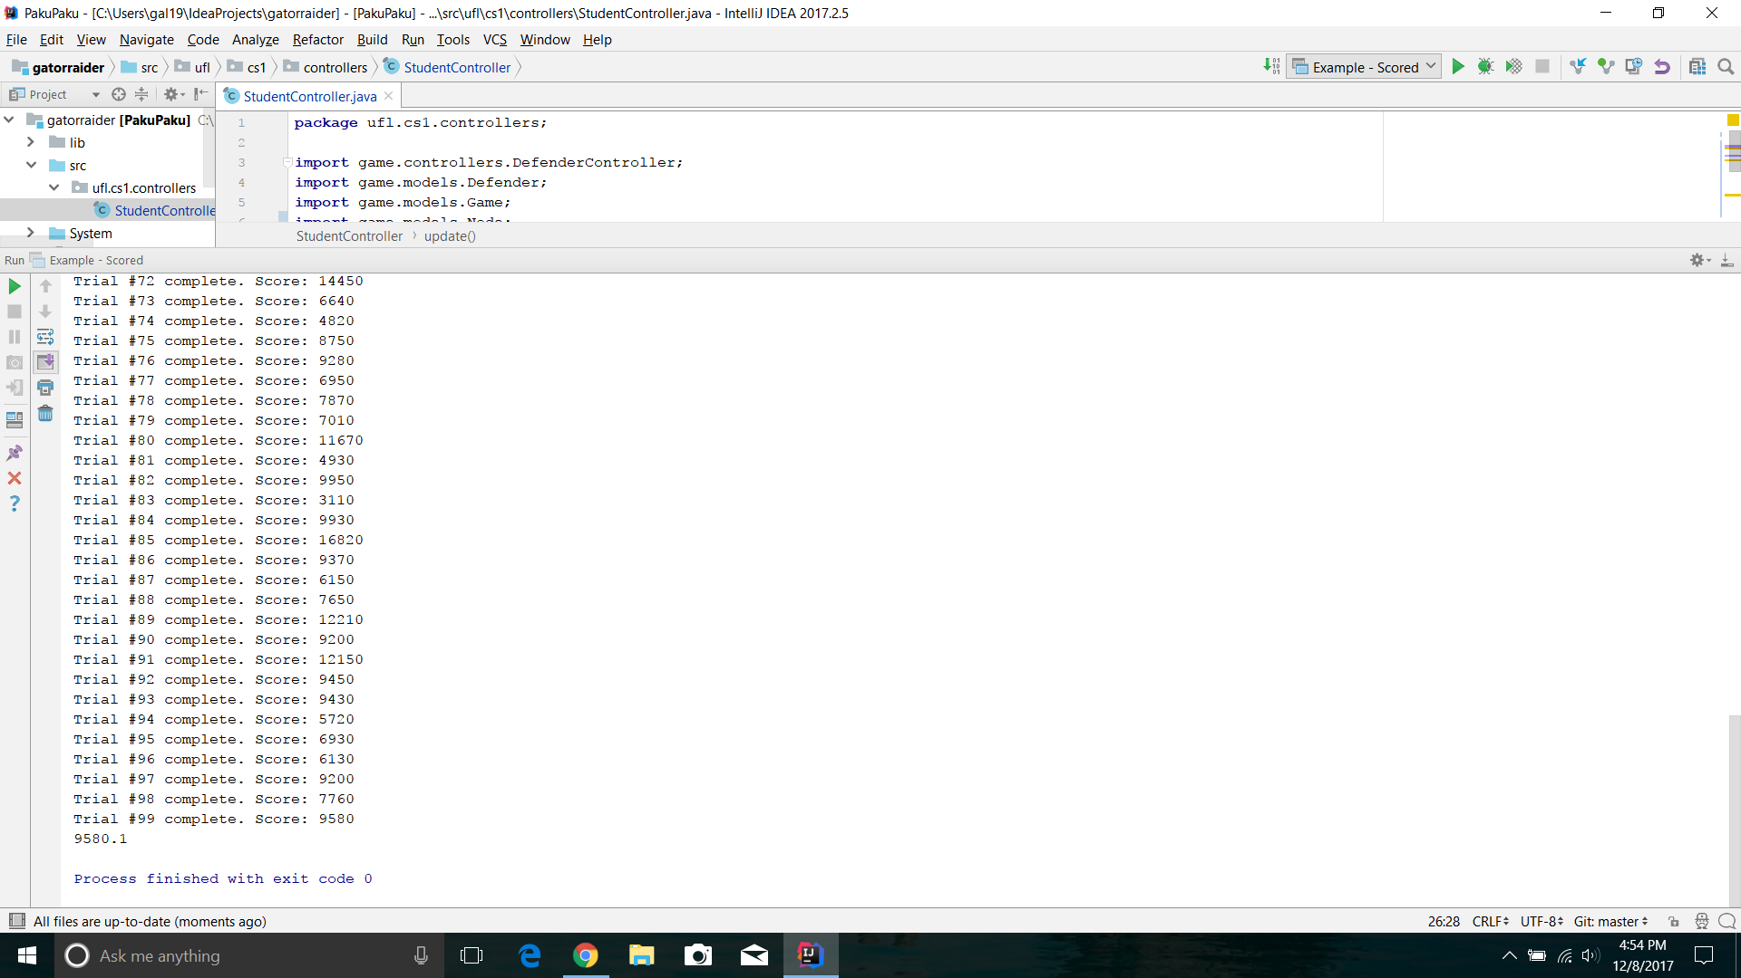

Our Student Score 7159.0 100% performance

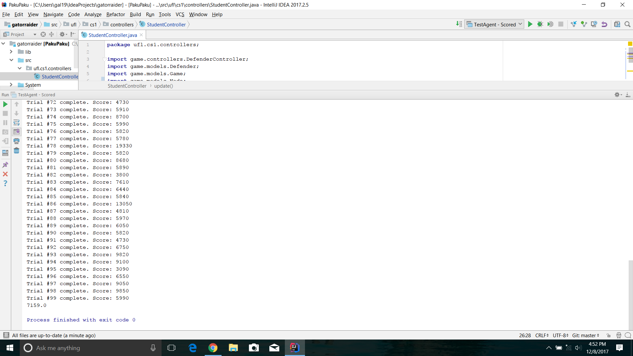

Java version and Platform: Java 1.8.0_144 and on an ASUS Windows 10 laptop. Latest version of the project was used with 100 trials.